**Docs to install gitlab =https://docs.gitlab.com/runner/install/linux-repository.html**

* **curl -L "https://packages.gitlab.com/install/repositories/runner/gitlab-runner/script.deb.sh" | sudo bash**

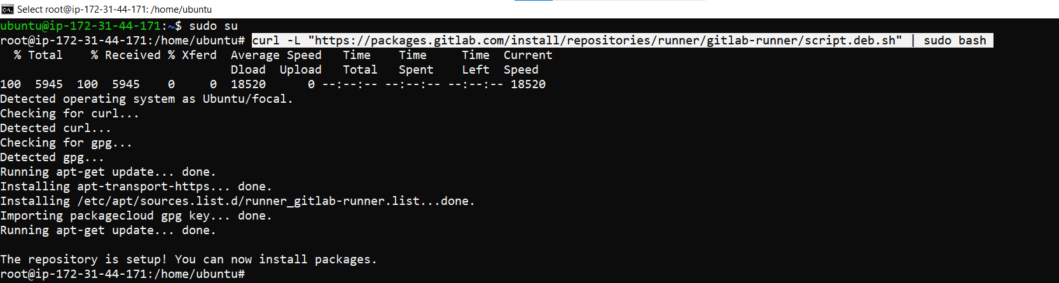

* **sudo apt-get install gitlab-runner**

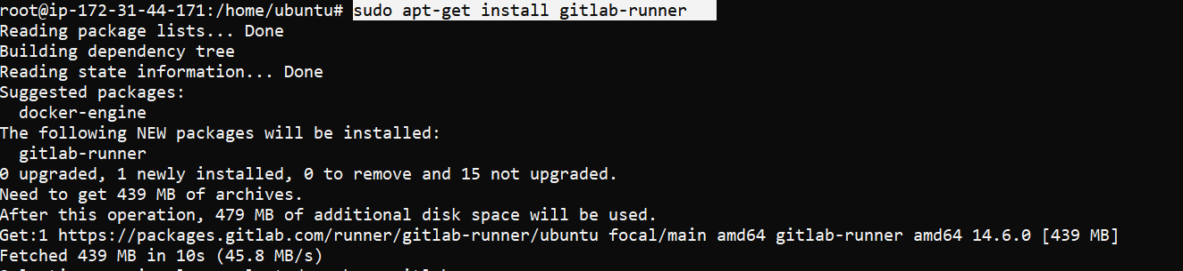

* **Sudo visudo**

**Add this line => gitlab-runner ALL=(ALL:ALL)ALL**

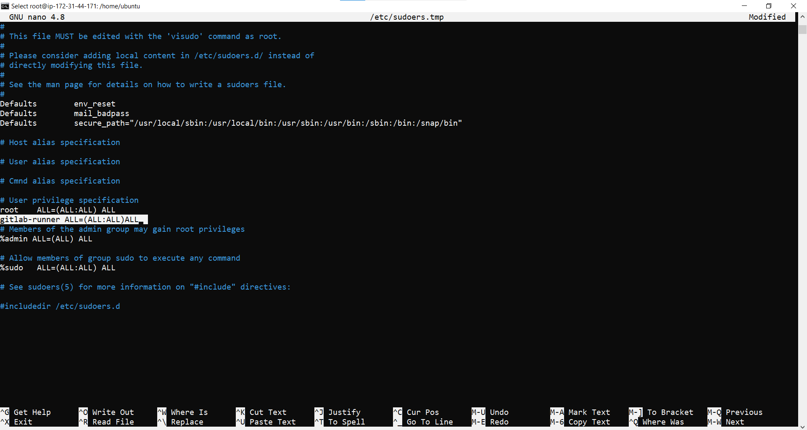

* **sudo gitlab-runner --version**

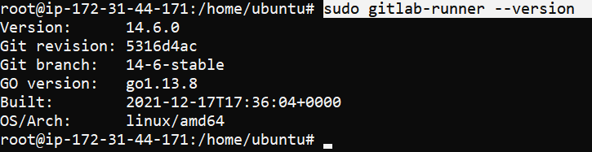

* **sudo gitlab-runner status**



* **Sudo gitlab-runner start**
* **Sudo gitlab-runner stop**
* **Sudo gitlab-runner restart**
* **Open this**
* **Copy, & enter this command to cli = sudo gitlab-runner register**

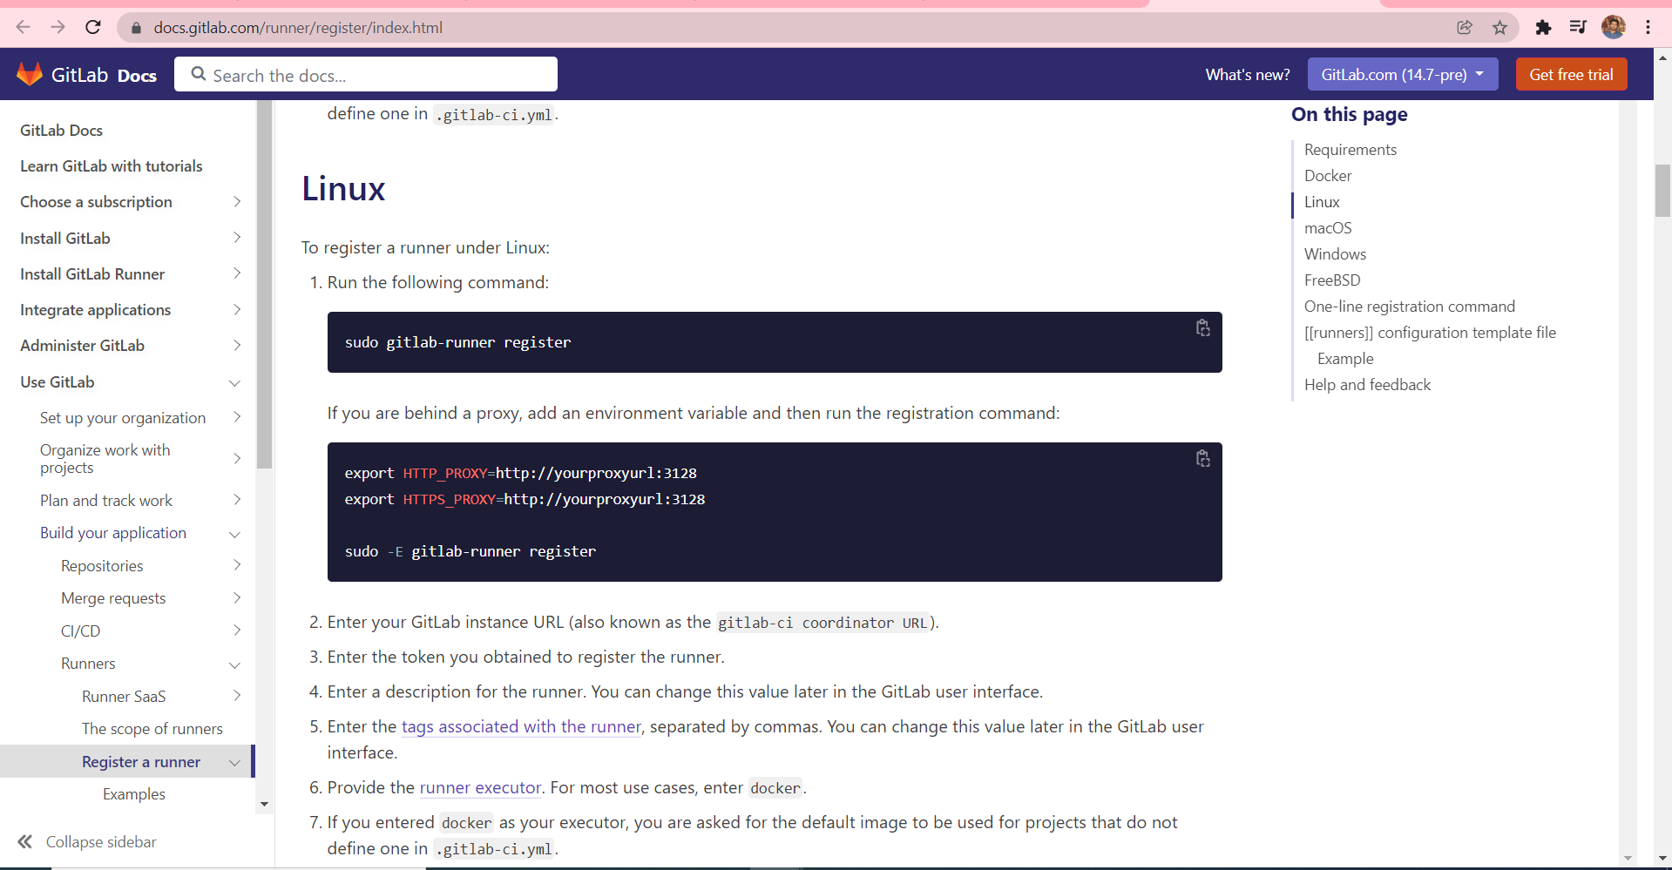

* **Open this path & copy this url & paste it console .**

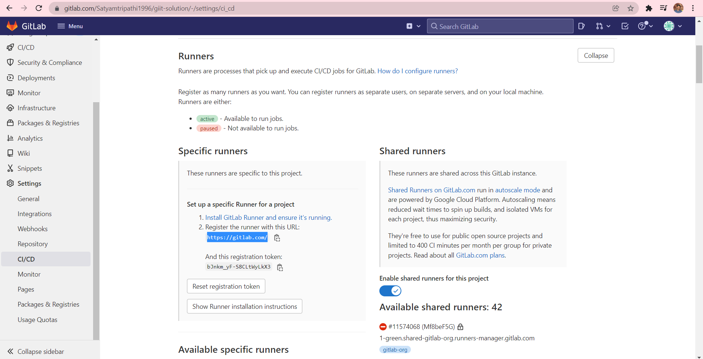



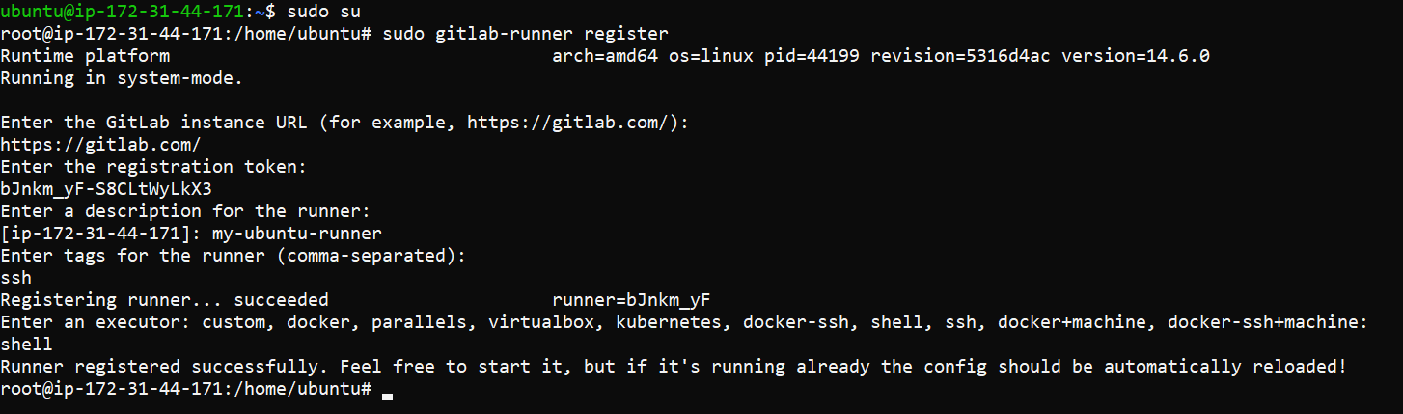

* **Now , again refresh a page we see our new available specific runner details .**

